[](https://www.google.co.in/url?sa=i&rct=j&q=&esrc=s&source=images&cd=&ved=2ahUKEwi8xvjnga_hAhVGU30KHb6xAzAQjRx6BAgBEAU&url=https%3A%2F%2Fwww.123rf.com%2Fphoto_14709538_child-write.html&psig=AOvVaw3CE_o3rTgeg8td3L9nMWeI&ust=1554211616645820)

[](http://www.google.co.in/url?sa=i&rct=j&q=&esrc=s&source=images&cd=&cad=rja&uact=8&ved=2ahUKEwio0o2Fgq_hAhXGT30KHda9BMcQjRx6BAgBEAU&url=http%3A%2F%2Fwww.attachmax.com%2F18%2FpostXVII%2Fboy-reading-books-clipart.html%2Fcartoon-boy-reading-clipart-reading-book-cartoon-miami-regarding-boy-reading-books-clipart-2&psig=AOvVaw36OkCWPJ0yKLQiLoUjNNmW&ust=1554212256014976)

[](http://www.google.co.in/url?sa=i&rct=j&q=&esrc=s&source=images&cd=&cad=rja&uact=8&ved=2ahUKEwjT1_PHgq_hAhVJAHIKHYBHDmUQjRx6BAgBEAU&url=http%3A%2F%2Fwww.google.co.in%2Furl%3Fsa%3Di%26rct%3Dj%26q%3D%26esrc%3Ds%26source%3Dimages%26cd%3D%26ved%3D%26url%3Dhttp%253A%252F%252Fdiysolarpanelsv.com%252Fdrink-water-clipart.html%26psig%3DAOvVaw3iWwbBdnBQy8vgojXKxgqG%26ust%3D1554212379825325&psig=AOvVaw3iWwbBdnBQy8vgojXKxgqG&ust=1554212379825325)

[](https://www.google.co.in/imgres?imgurl=http%3A%2F%2Fwww.amisvegetarian.com%2Fwp-content%2Fuploads%2F2018%2F09%2Fboy-clipart-smiling-boy-boy-clipart-boy-smile-png-image-and-clipart-for-free-music-clipart.jpg&imgrefurl=http%3A%2F%2Fwww.amisvegetarian.com%2Fboy-clipart-house-clipart%2Fboy-clipart-smiling-boy-boy-clipart-boy-smile-png-image-and-clipart-for-free-music-clipart%2F&docid=MDKVhrws5tD-SM&tbnid=6jmgOw9NXRAZXM%3A&vet=10ahUKEwjmirTRgq_hAhWIYysKHYiCDU4QMwhqKB8wHw..i&w=536&h=800&bih=660&biw=1366&q=Clip%20art%20Picture%20for%20smiling&ved=0ahUKEwjmirTRgq_hAhWIYysKHYiCDU4QMwhqKB8wHw&iact=mrc&uact=8)

[](https://www.google.co.in/url?sa=i&rct=j&q=&esrc=s&source=images&cd=&ved=&url=https%3A%2F%2Fwww.istockphoto.com%2Fillustrations%2Fboy-singing&psig=AOvVaw1_fpeodw1HxLPGM2rr_PXW&ust=1554212477739691)

[](https://www.google.co.in/imgres?imgurl=https%3A%2F%2Funixtitan.net%2Fimages%2Fballerina-clipart-dance-practice-1.png&imgrefurl=https%3A%2F%2Funixtitan.net%2Fexplore%2Fballet-dancer-clipart%2F&docid=NAzXzAZiHHD40M&tbnid=3kza_RNjeiJs8M%3A&vet=10ahUKEwjY9KDxgq_hAhVTWX0KHWtkAj4QMwipAShjMGM..i&w=1447&h=2347&bih=660&biw=1366&q=Clip%20art%20Picture%20for%20dancing&ved=0ahUKEwjY9KDxgq_hAhVTWX0KHWtkAj4QMwipAShjMGM&iact=mrc&uact=8)

[](https://www.google.co.in/imgres?imgurl=https%3A%2F%2Fimages.cdn3.stockunlimited.net%2Fclipart%2Fboy-raising-hand_1427045.jpg&imgrefurl=https%3A%2F%2Fwww.stockunlimited.com%2Fsimilar%2F1285912.html&docid=-6qTQtLOedTC8M&tbnid=rSaEf_B-RnWeUM%3A&vet=10ahUKEwjH_euHg6_hAhVRfSsKHX8UAfYQMwhxKCYwJg..i&w=200&h=200&bih=660&biw=1366&q=Clip%20art%20Picture%20for%20sitting&ved=0ahUKEwjH_euHg6_hAhVRfSsKHX8UAfYQMwhxKCYwJg&iact=mrc&uact=8)



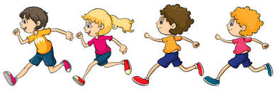



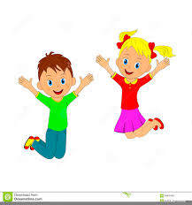

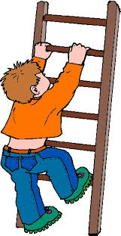

[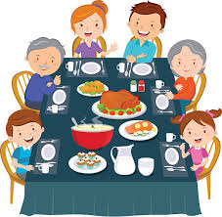](https://www.google.co.in/imgres?imgurl=https%3A%2F%2Fmedia.istockphoto.com%2Fvectors%2Fthanksgiving-dinner-family-dinner-vector-id507874134%3Fk%3D6%26m%3D507874134%26s%3D612x612%26w%3D0%26h%3DiVs0y4I10pXsL-hWLhbI6uirsIoa_51dsT_5TZ0UMN8%3D&imgrefurl=https%3A%2F%2Fwww.istockphoto.com%2Fillustrations%2Fdining-table&docid=JcjyUEzc9EJuBM&tbnid=SdSJ3pGEKml65M%3A&vet=10ahUKEwiD74z1g6_hAhXCXisKHcZmC_0QMwhnKB0wHQ..i&w=612&h=601&bih=660&biw=1366&q=Clip%20art%20Picture%20for%20eating&ved=0ahUKEwiD74z1g6_hAhXCXisKHcZmC_0QMwhnKB0wHQ&iact=mrc&uact=8)

